**Card Demo Documentation**

1. ***Title Page***
   1. Game Name – Teen Patti/ Card Demo (Temporary) .
2. *Game OverView.*
   1. Game Concept

* Multiplayer Card Game.
  1. Target Audience
* 13+
  1. Game Flow Summary (How players move through game), framing interface with the game itself.
  2. Game Visuals.

1. *Game Play and Mechanics*
   1. Game Play

* This is a similar game as POKER. In Teen Patti, 3 cards are distributed among the available players in the room. In every single round, player will autobet a minimum wage to play.

After that they can decide their move as in :

* + **See The Deck In Hand.:-** Players can see their card and bet or fold confidently.
  + **Double The Bet. :-** If a Player Doubles the bet, All other players must meet the bet amount, if not they can fold.
  + **Fold :-** If a player is not confident about his cards, without betting anymore at this round, he can fold to save his value.
  + **Side Show :-** (Need to check this out a bit)

After all the players have meet the wage amount and turns, winner will take the lot according to the Teen Patti Rules. This Continues until other players leaves or loses all his value.

* 1. Mechanics. (What are the Rules of the Games. The is the model of the universe that the game works under. It can be very large section.)
* 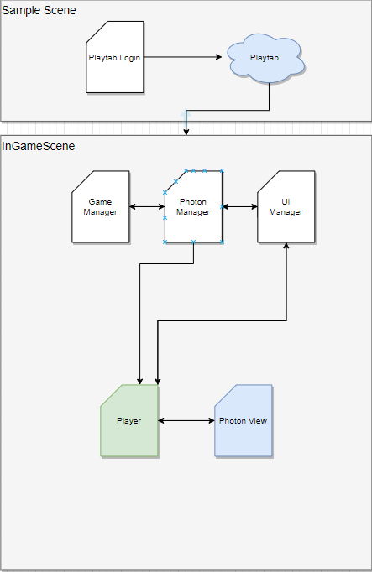
  1. Game Options.

1. *Story, Settings and Character*
   1. Story and Narrative
   2. Game World
   3. Characters
2. *Levels*
   1. Levels, each levels should include a synopsis, the required introductory material (and how it is provided), the objectives, and the details of what happens In the level. Depending on the game this may include the physical description of the map, the critical path that the player needs to take, and what encourages are important or incidental.

* There Are no levels
  1. Training Level
* No Training Levels.
  1. Assessment. How are the knowledge/competencies developed in the game tested?

1. *Interface*
   1. Visual System. If you shave a HUD, what is on it? What menus are you displaying? What is the camera model?
   2. Control System – How does the game player control the game? What are the specific commands?
   3. Audio, music, sound effects
   4. Help System